**Pre requisites**

* Selenium library is required to run the code
* Chrome installed on the system
* Chrome driver downloaded (version compatible with chrome)

**Flow of Code**

* Data is first cleaned by removing the duplicates and removing invalid entries

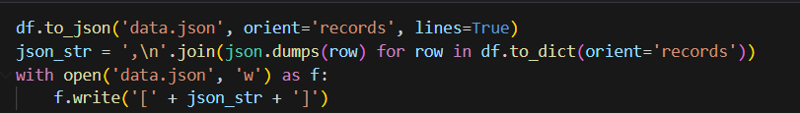

* In the *setup_driver* function various browser options are setup and download directory is defined. After all the prefs and options setting up, new Chrome Webdriver is created which is further used in the task

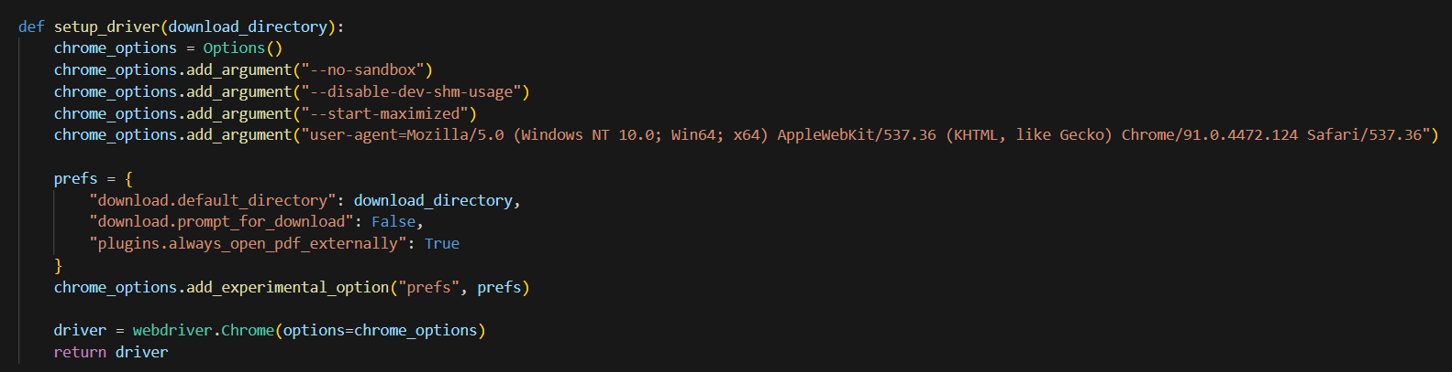

* *login_to_trendlyne* function is defined to automate the whole login process on trendlyne website. By seeing the inspect pages of website attribute names of input fields were figured out and via web driver the field is located and by *send_keys* option, username and password is filled and finally submitted. Due to options in driver, the pdf is downloaded as soon as it is submitted. All the errors are also well defined in case if some error occurs in the process.

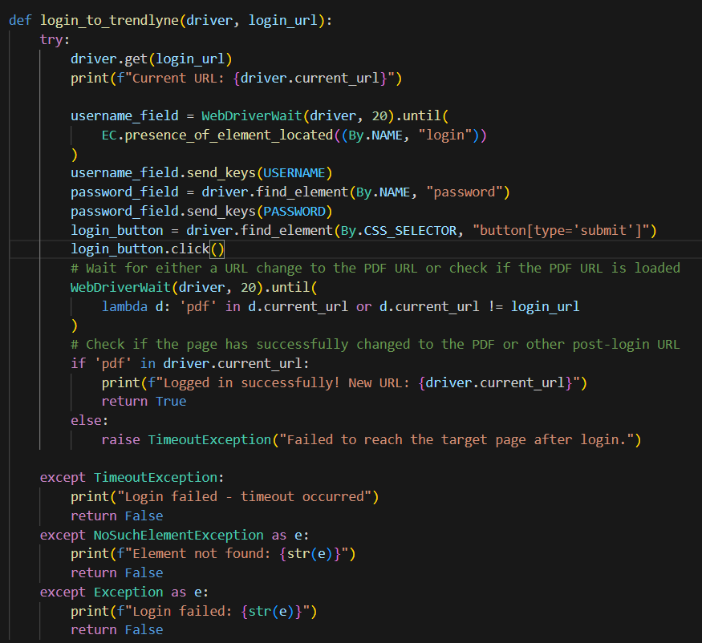

* *check* function is defined to check if the required pdf is downloaded in directory. This is just a check function to make sure everything went ok in the previous functions.
* Finally is the *main* function which first extracts all the urls from data.json corresponding to the organisation and then iterate over it and run above defined functions to download pdfs